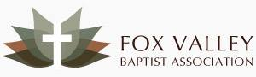
Father’s Day Week Of Prayer and Offering
June 10-17, 2018
Please Pray for:

Day 1–29 Churches Making Up Fox Valley Baptist Assoc.
Day 2–Summer Meeting With Saul Ebema July 9
Day 3–FVBA Children’s Camp July 23-27
Day 4–FVBA Youth Camp 8/2-5 & Youth Rallies 9/28 &
12/1
Day 5–Summer Mission Outreach to Race Track Families
Day 6–Annual Meeting-Randy Blan Preaching Oct. 8
Day 7–Expect Great Things Leadership Conf. Nov. 3
Day 8–Dr. Mark Inman-Director Of Missions/Admin Team

Please Give:

- Thank you for your mission giving to Fox Valley Baptist Association through your local church.

- Thank you for your special designated offering for Fox Valley Missions for the Fathers’ Day offering. This offering helps provide travel expense for special speakers and materials for conferences and ministries listed above.

For more information see FBVA website
www.fvba.us and Facebook page.

